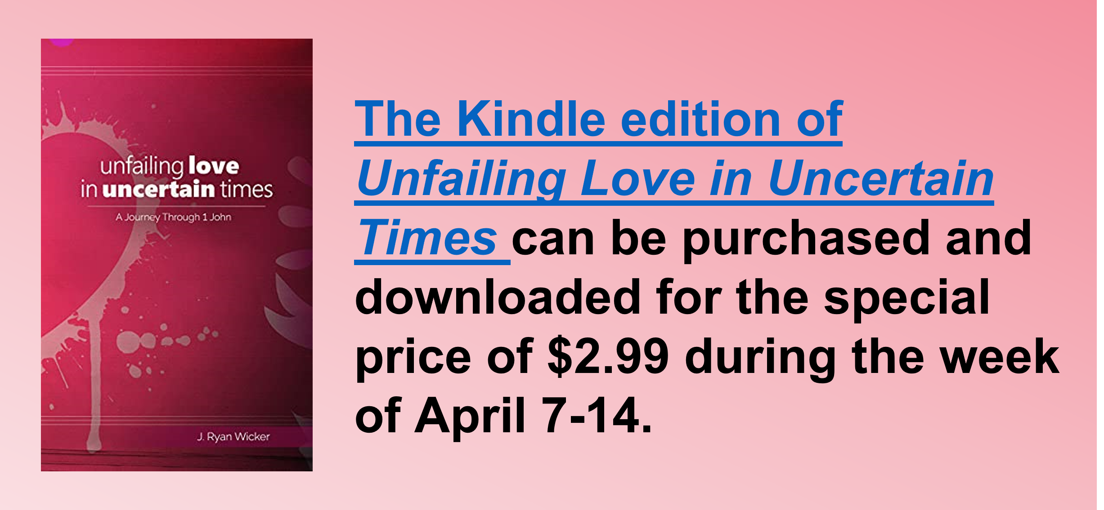
Study Series: Unfailing Love in Uncertain Times
Author: J. Ryan Wicker

Lesson Title: “Know and Guard” (pp. 90-102)
Session 7
April 16, 2023

The main point of this lesson is: God gives assurances of truths we can know and expects us to guard ourselves against that which undermines those assurances.

Focus on this goal: To help adults rest in the assurances of God

Key Bible Passage: 1 John 5:13-21

Before the Session

Bring a variety of items that not everyone knows how to use (such as countertop multi cooker, multi-tool pocket knife, graphing calculator, crochet hook, slide rule, rotary phone, etc.). (Step 1)

During the Session

Step 1. Create Interest / Jumpstart Discussion

Say: I’ve brought a few items that not everyone knows how to use. Hold them up one at a time and ask: Does anyone know how to use this confidently? If you have a volunteer, invite him to briefly describe how to use the item and whether he uses it on a somewhat regular basis.

Acknowledge: You may have some of these items in your home, but if you don’t know how to use them, they aren’t an effective part of your life. Point out that, in this last session from Unfailing Love in Uncertain Times, we’ll consider how God’s truths are meant to be fully known, understood, and used in our everyday lives.

Step 2. What We Can Know

Explain that, in this last portion of John’s first letter, you’ll explore five things John wants us all to know. Mention that these would have been John’s last thoughts as he wrapped up his letter.

Invite a volunteer to read 1 John 5:13. Use the Day One content (pp. 90-92) to help learners truly grasp that concept of “eternal life.” Stress the fact that it doesn’t mean simply “eternity in heaven” but instead reveals an eternity in God's presence.

Direct learners’ attention to the word “know” in 1 John 5:13, and use the paragraph (p. 91) that begins with the phrase “This is something we can know . . .” to explore the deep meaning of this Greek word.

Step 3. God Answers Prayer (5:14-17)

Invite a volunteer to read 1 John 5:14-15. Say: John assures us here that we can have confidence when we pray; how confident are you in your daily prayer time?

Use the content from Day Two (p. 92) to highlight the fact that our confidence comes from the merits of Christ. Read Romans 12:1-2, pointing out that God’s will is good, pleasing, and perfect; we must submit to God’s will. Share a time when you struggled to submit to God’s will, but received a blessing that came from doing so.

Invite a volunteer to read 1 John 5:16-17. From the Day Two content (pp. 93-94) stress the importance of intercessory prayer.

Step 4. We Can Overcome Sin (5:18)

Remind learners that you’re still exploring five things John wants us all to see and know with confidence.

Invite a volunteer to read 1 John 5:18 aloud. Acknowledge that this verse seems hard to understand. Use the content in the first paragraph of Day Three (p. 94) to help learners see that we struggle with sin, but it does not rule us.

Read the following sentences from the next paragraph (p. 94): “As believers, it is important that we have the mindset of overcomers when it comes to sin. Sin has been defeated.” Ask: How can we daily remind ourselves of the truth that sin has been defeated? What must we do to live out that truth?

Step 5. We Belong to God (5:19)

Invite a volunteer to read 1 John 5:19. Request another volunteer look up the verse in a Bible software app on her phone and read the verse from several different translations. Use those, along with the content for Day Four (pp. 96-97), to help believers find certainty in what it means to belong to God.

Read the paragraph (p. 96) that begins, “Dear, Christian, . . .” and add your own statements to it as the Holy Spirit brings truth to your mind.

Invite a volunteer to read 1 John 5:20. Read the Day Four paragraph (p. 97) that begins “Of all the things . . . .” As a group, consider the beautiful truth that reveals God’s love for us: He made Jesus known and available to us! We cling to Him in the midst of a chaotic world.

Step 6. Be on Guard for Idols (5:21)

Say: You might be a little shocked at John’s closing words in this letter. Invite a volunteer to read 1 John 5:21. Ask: What might have made John close with this quick warning?

Use the information from the second paragraph of Day Five (p. 98) to explain the pagan background of many of John’s readers. Read the following statement from the third paragraph of Day Five (p. 99): “The secular idols of rugged individualism, materialism, humanism, post-modernism, and theological liberalism are prevalent all around the United States.” Emphasize that these idols don’t look like man-made statues from John’s time, but they are just as real.

Step 7. Practical Application – Live Out the Lesson

Ask: As we finish our study of John’s first letter today, what will you remember about it? Invite a few volunteers to share.

Read the Day Five paragraph (p. 99) that begins “If we are to survive . . .” as a closing for the study and your time together.

Close in prayer, asking that God would supernaturally empower adults to remember John’s words and live them with full love and knowledge, despite—or more specifically because of—the uncertainty of the times.

