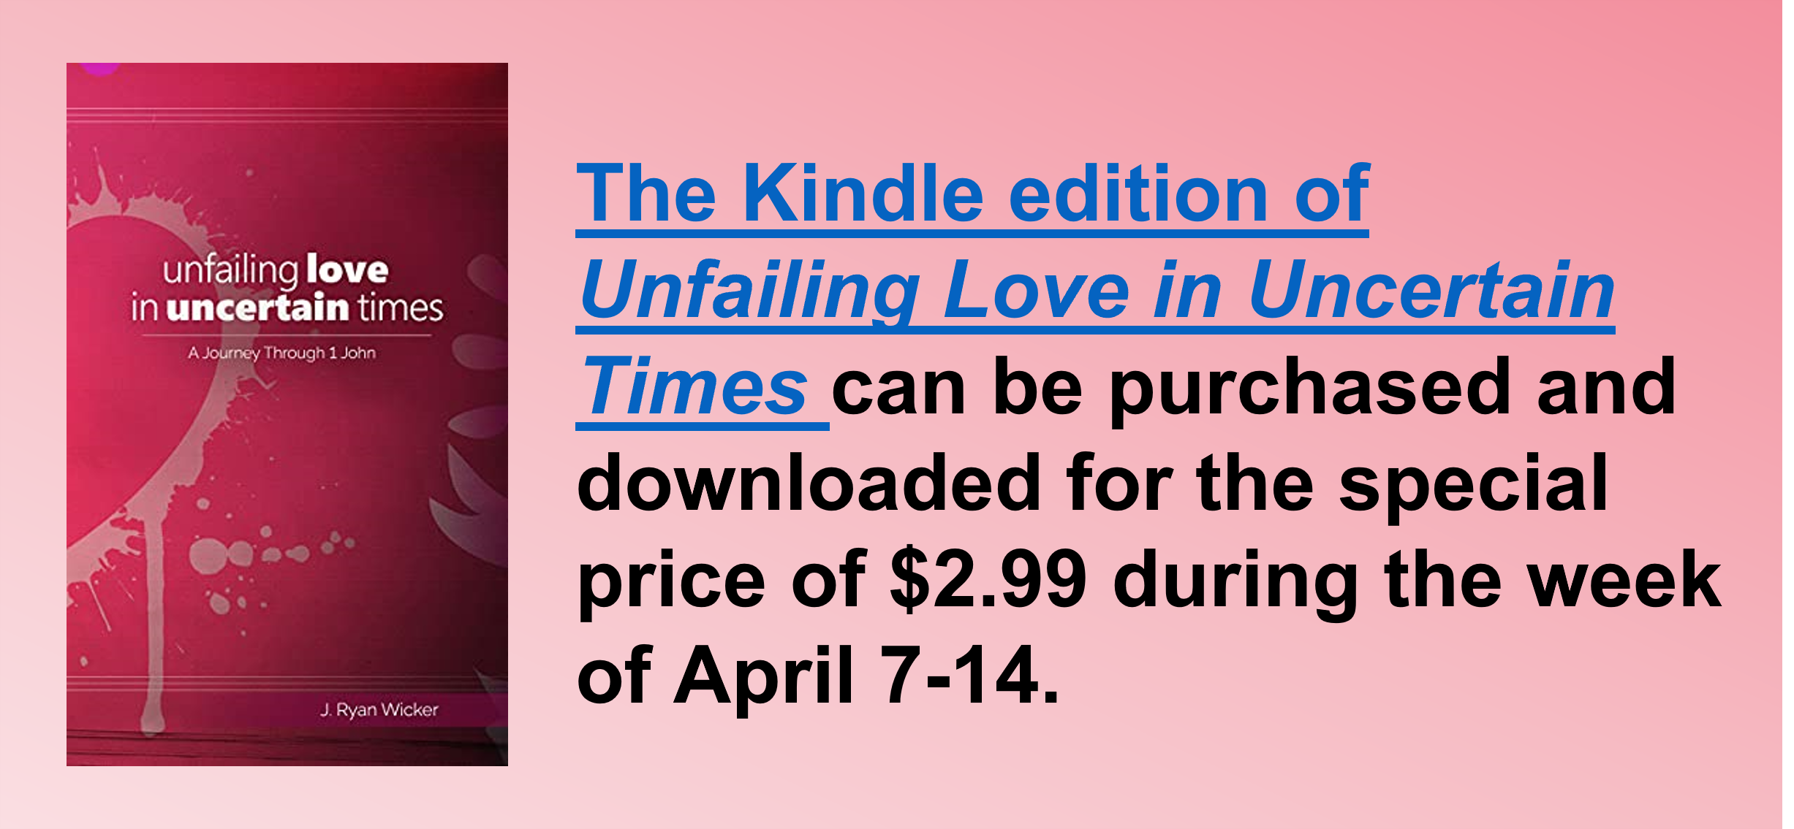
Study Series: Unfailing Love in Uncertain Times
Author: J. Ryan Wicker

Lesson Title: “Living Love and Benefits of Love” (pp. 48-61)
Session 4
March 26, 2023

The main point of this lesson is: Love not only determines how we relate to others, but how we relate to God.

Focus on this goal: To help adults love others sacrificially that they may have confidence in relating to God

Key Bible Passage: 1 John 3:10-24

Before the Session

Review the account of Cain and Abel by reading Genesis 4:1-9. (Step 3)

During the Session

Step 1. Create Interest / Jumpstart Discussion

Request a show of hands as you ask: Who had a beloved pet dog or cat when you were growing up? Invite a few volunteers who raised their hands to briefly talk about their furry childhood friend.

Then ask: Who had a bad experience with a dog or cat when you were young? Again invite one or two of those volunteers to briefly tell about their experience.

Ask everyone: Would you say that your early experience with a dog or cat shaped your opinion of them and your relationship with them today? Explain that, in today’s passage, we’ll explore how love for God and love for others is also connected.

Step 2. Live Love: Truth in Action, Part 1

Invite a volunteer to read 1 John 3:10-11 aloud. Say: John was clear: Jesus followers should love one another. But what does that look like in our day-to-day lives?

Use the author’s example of how some people loved others during the COVID-19 pandemic (p. 48), but move beyond that situation, as well.

Direct learners to the bulleted verses about love in Day One (p. 49) and invite them to share what love looks like according to them. If you have ever developed a close bond with someone with Christ as your only link, share that story.

Step 3. Live Love: Truth in Action, Part 2

Invite a volunteer to read 1 John 3:12-15. Then invite a different volunteer to read Matthew 5:22. As a group, consider how these two passages reveal the same truth.

Use the Day Two content (p. 51) to point out how Cain exhibited the very hatred addressed by both Jesus and John: he pretended to be a worshiper, but he actually hated the righteousness of his brother.

Point out that John’s words instruct us not only to have courage to continue living righteously even when the world hates us, but also to check our own hearts toward other believers.

Reread 1 John 3:14 and ask: How does this verse give us a real-life reason to deal with ungodly hatred as well as to analyze our own hearts?

Step 4. Live Love: Truth in Action, Part 3

Invite a volunteer to read 1 John 3:16-18 aloud. Read the opening paragraph of Day Three (p. 52) and engage learners in discussing how Jesus perfectly exemplified the life of sacrifice and suffering.
Then ask: We see that John held Jesus up as our example; but how seriously do we take the instruction to lay down our lives as He did? Point out that many believers would be willing to die for their faith, but they’re less wiling to be sacrificial in their everyday lives.

As a group, consider what it looks like to be sacrificial in our everyday lives. You may want to suggest giving of our time, talents, and money; supporting others emotionally and spiritually; not insisting on receiving our rights and respect.

Step 5. The Live-Giving Benefits of Love, Part 1

Invite a volunteer to read 1 John 3:19-20. Say: This is a tricky topic, because we’re told that our hearts can be deceitful, but that we can also find confidence through our hearts.

Use the Day Four content (pp. 54-55) to help learners see that God’s presence in a believer changes one’s heart, and a God-ordered heart is honest before Him and others.

Point out that our hearts may still be affected by anxiety, doubt, inadequacy, and confusion, so we must make sure our hearts are grounded in the Word of God and led by the Holy Spirit.

Encourage learners to spend time each day hearing the Lord speak to their hearts, about their hearts, and giving their hearts rest.

Step 6. The Live-Giving Benefits of Love, Part 2

Invite a volunteer to read 1 John 3:21-22 aloud. Read the opening paragraph of Day Five (p. 56) and share a recent time of prayer in which you were struck by the blessing and privilege of speaking to God.

Ask: But let’s be honest; does anyone not sometimes struggle to pray? Use the Day Five content (pp. 56-57) to help learners find confidence in God and their salvation to realize their prayers are not dependent upon how well they pray, but on the One who hears and acts.

Read or summarize the paragraph (p. 57) that begins, “This truth frees us . . . .”

Use the content (pp. 57-58) to consider the name (identity) of Jesus and what it means when we believe in Him and believe Him.

Step 7. Practical Application – Live Out the Lesson

Read in sections and discuss the last two paragraphs of Day Five (p. 58).

Say: Love isn’t just a simple word that points to a simple feeling; in God’s kingdom, it’s a strong emotion and commitment from the Father, acted out upon us, His children. God’s love leads us to live according to the fact that Jesus is Savior and Lord.

Encourage learners to consider their own hearts and belief systems this week, being sure they align with the truth of the gospel.

Close in prayer.

